Ideation Phase
Brainstorm & Idea Prioritization Template
Date | 10 February 2026
Team ID | LTVIP2026TMIDS71782
Project Name | Optimizing User, Group, and Role Management with Access Control and Workflows
Maximum Marks | 4 Marks

Step 1: Team Gathering, Collaboration & Problem Selection

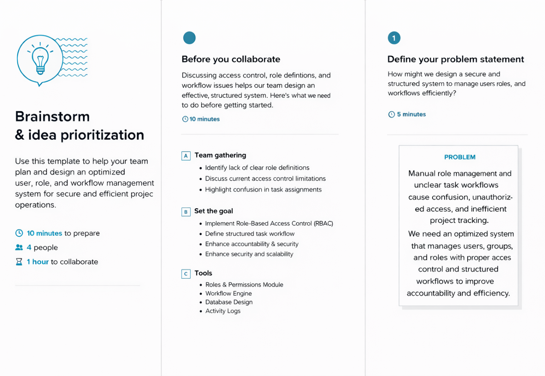

Step 2: Brainstorm, Idea Listing & Grouping

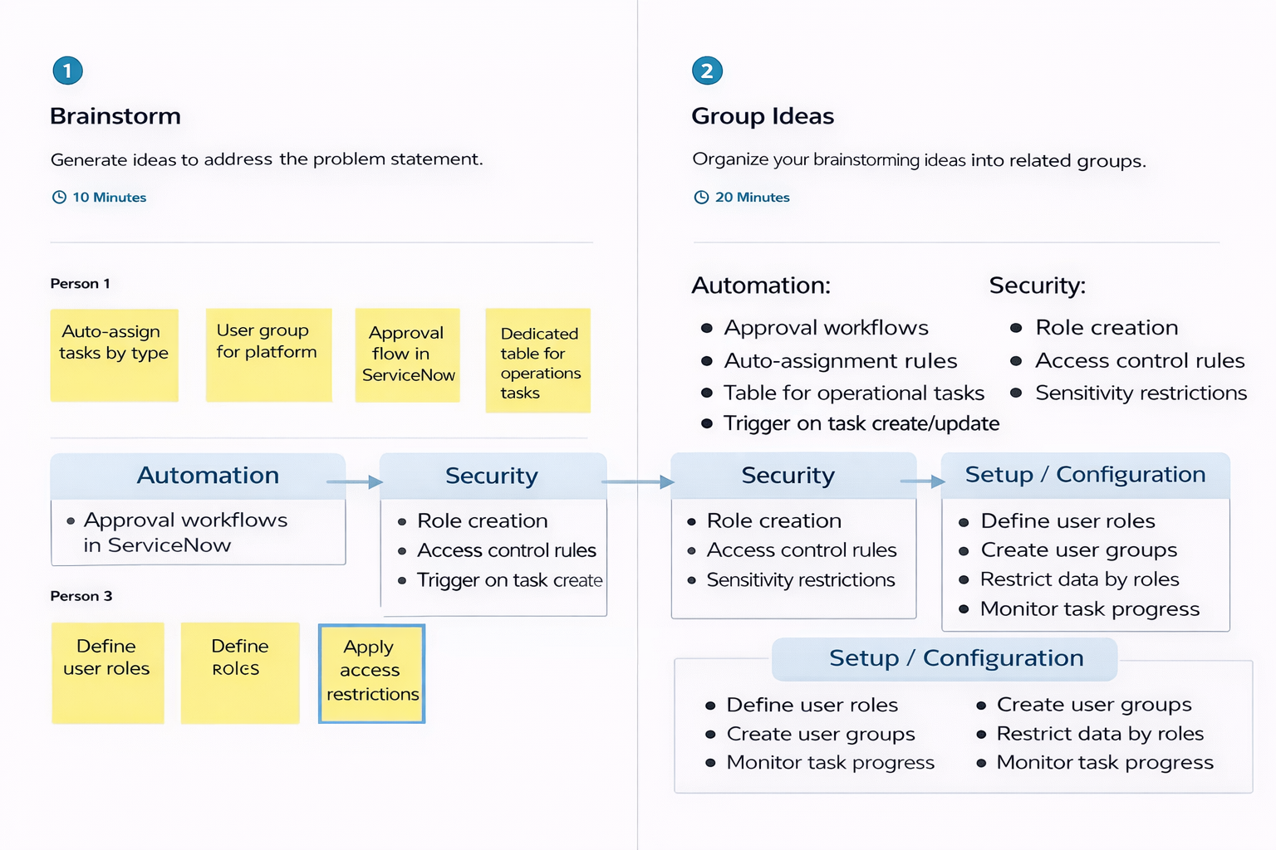

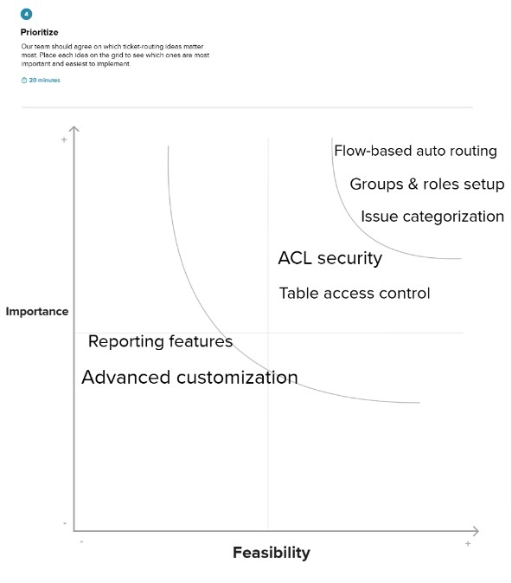
Step 3: Idea Prioritization

